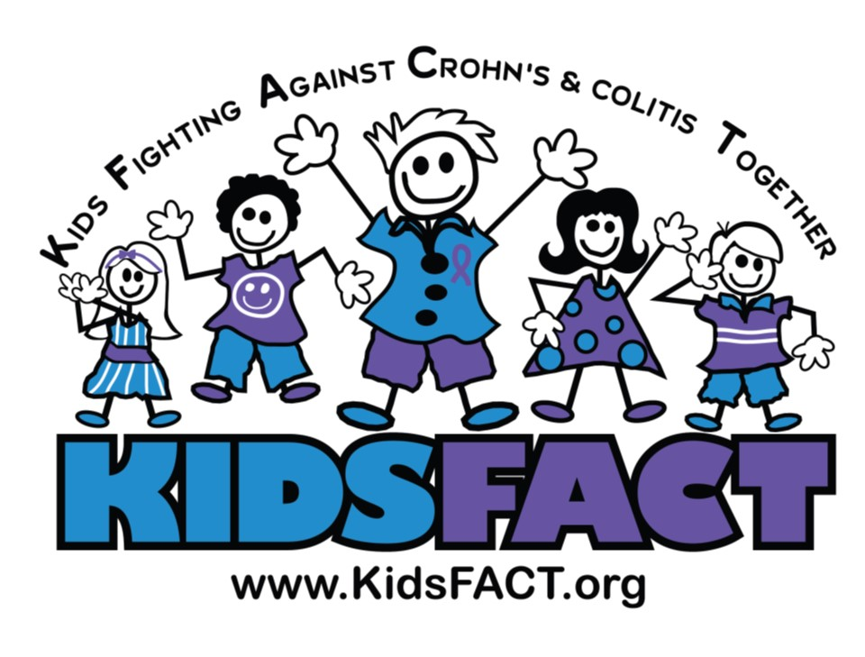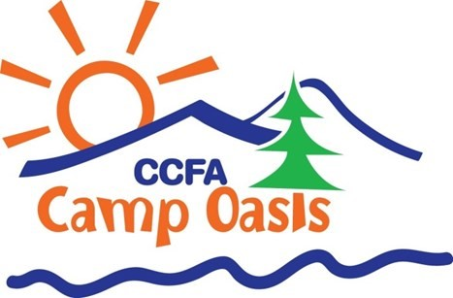
Win a Camp Oasis Sponsorship from KIDSFACT Free Drawing
KIDSFACT is sponsoring (3) GI for Kids IBD patients to attend this years Camp Oasis Summer Camp Program at Camp Will-A-Way in Winder, Georgia. If you are interested in your child attending this camp and want your child’s name in the drawing, please fill out the sheet below and return it to the GI for Kids front office on the 5th floor. The drawing will be held on Thursday April 16, 2019. For more information about the camp and all the details for attending the camp, please visit the CCFA website at https://www.crohnscolitisfoundation.org/get-involved/camp-oasis
KIDSFACT will provide the camp fee and a $150.00 travel allowance for the child. The family is responsible for all transportation arrangements and camp registration.
Camp Oasis of Georgia
Session Dates: June 14th-June 19th Grades: 2-11 in Fall of 2020
Host Site: Camp Will-A-Way - Winder, GA
A Fun Place for Learning, Playing, and Healing
Dealing with inflammatory bowel disease (IBD) as a child is extremely challenging. That is why the Crohn's & Colitis Foundation of America (CCFA) proudly established Camp Oasis over a decade ago. This co-ed residential summer camp program enriches the lives of children with Crohn's disease and ulcerative colitis by providing them with a safe and supportive camp community.
A Life Changing Experience
Since all the campers (and many of the adults) at Camp Oasis are living with IBD, our supportive community allows them to:
- See that they are not alone
- Try all sorts of new sports and activities
- Create friendships with people who truly understand them
- Gain confidence and independence
- Put aside their troubles, and just be a kid
___________________________________________________________________________________________________________________
Child’s Name: ________________________ Parent’s Name:_______________________ Phone: ____________________
Address: ________________________________________________ Email:__________________________
IBD Diagnosis: ______________________ Child’s Grade in Fall 2020: ____

